Presentation ID: Pxx Type of Presentation: Poster/Oral

Instructions for preparing Abstracts

A. First¹*, B. Second², C. Third^{1,3}
1 MEON-CENIMAT/i3N, FCT-NOVA, Portugal; 2 XYZ, University of XYZ, Country; 3 WUV
The abstract will be part of the book of abstracts of the VIII Annual Meeting I3N 2023 which will be distributed to all participants. Abstracts must be typed in English. This instruction page is an example of the format and font sizes to be used. This text will be used in the book of abstracts so please treat it as though it is the final version.
Here follows detailed instructions on how to produce an abstract. Authors should use Microsoft Word or an RTF-able program like Open-Office to produce their abstract. The right and left margins should have 2 cm and top and bottom margins 1 cm. Only Times New Roman font is accepted. The title of the paper is typed in boldface 18 point characters and centered on the page. The author’s name is typed in 14 point and centered. Directly under the author’s name, and also centered on the page, is the author’s affiliation italicized and the e-mail address of the corresponding author. Try to use acronyms for affiliations. Authors name and affiliation are in blue. The main text should be typed single spaced using 12 point characters, and references 12 point characters. Paragraphs are a single line space separated by 6 pt space (before paragraph) with no indentation. The text of the abstract is written in one column and justified. Figures and Tables may be inserted and centered within the page (Fig. 1). The references should appear in the text as [1] and should be listed at the end of the abstract text.
Note that the abstract should fit in one page only (all included).
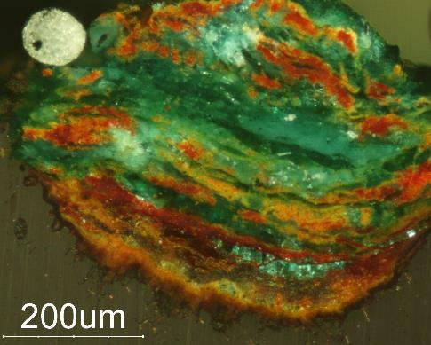
Fig. 1. OM image of pit corrosion in bronze (polarized light). (do not forget to scale images).

References
[1] J. S. Park, W. J. Maeng, H. S. Kim, and J. S. Park, Thin Solid Films 520, 1679-1693 (2012).
[2] (Times New Roman 10)

